What’s Up?

For school leaders of Independent Schools inspected by Ofsted

Volume 1: October 2018

**Ofsted News**

Includes relevant news published since the beginning of Autumn 2018 term. The focus is on how changes will affect non-association independent schools.



**21 September 2018:** **HMCI commentary: curriculum and the new education inspection framework**

Her Majesty’s Chief Inspector, Amanda Spielman talks about the research that has been conducted into the primary and secondary curriculum. This research has been conducted over 2 phases involving a total of 64 schools and a 3rd phase is almost complete. The findings from this research will be fed into the consultation on the 2019 inspection framework.

As leaders of independent schools, you are probably thinking – our curriculum is determined by the Independent School Standards (2014), not the national curriculum so why should we care? You are right, the content of your curriculum will still be governed by standard 2 but based on this commentary by HMCI, the 2019 inspection framework will have new criteria about what inspectors will consider when making judgments about other aspects of the curriculum, not just the content. I think most of these criteria will be under the “Effectiveness of leadership & management” heading or whatever the new heading will be for the leadership area of judgment. It might not be surprising to find that the curriculum will be added as a separate, 5th area of judgment!

After reading this commentary I have drawn up a list of some of the criteria that I think will be on the consultation document for the 2019 framework:

* Leaders’ knowledge about curriculum design
* The curriculum and the local context
* How well the curriculum is implemented
* The extent to which pupils, particularly pupils with SEN can access the school’s full curriculum offering
* Effectiveness of the curriculum review process

I would advise school leaders to start thinking about their current standing in these areas in preparation for the new framework.

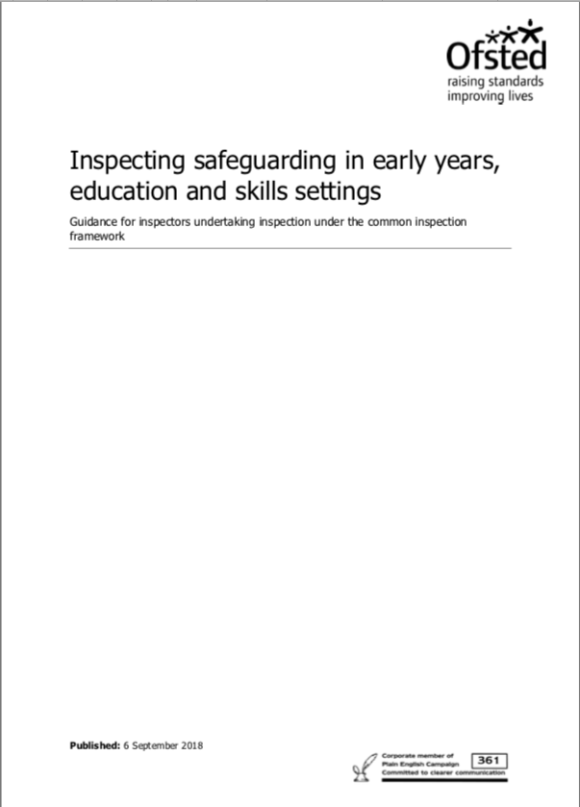

**6 September 2018: Inspecting safeguarding in early years, education and skills**

Ofsted published their updated guidance which outlines how they will be inspecting safeguarding from September 2018 onwards. It includes important new requirements from the DfE’s September 2018 version of Keeping Children Safe in Education which you need to incorporate into your safeguarding practice for example:

* where reasonably possible, schools should now hold more than one emergency contact number for each pupil - this is something you will need to consider when admitting pupils to your school, when adding them to the admissions register, when preparing the emergency contact list during the risk assessment process that takes place before pupils go on educational visits or other activities outside the school
* the statutory definition of safeguarding has been updated and the list of specific issues which may require safeguarding action now includes homelessness, peer on peer abuse, so-called honour-based violence, child criminal exploitation and county lines - this means staff need to know how to identify pupils who are affected by these issues and what to do if they suspect that pupils are suffering this type of abuse. The DSL can use safeguarding updates to train staff, details about these issues can be found in the DfE's Keeping Children Safe in Education (September 2018) from page 76 onwards. The NSPCC is also a good source of information about identifying some of the issues listed above and knowing what to do next.

Some of you might be interested to know that disqualification by association no longer applies to schools!

The updated guidance can be found [**here**](https://assets.publishing.service.gov.uk/government/uploads/system/uploads/attachment_data/file/739419/Inspecting_safeguarding_guidance_100918.pdf) and if you want to focus only on what has changed, download the list of changes [**here**](https://docs.wixstatic.com/ugd/56954a_c35eea665e6845cfaf4d94bf3048c1d1.docx?dn=List_of_changes_to_Inspecting_safeguardi)

**Book of the Month**

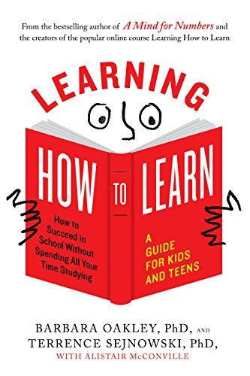

**Book title**

Learning how to Learn: How to succeed in school without spending all your time studying

**Authors**

Barbara Oakley, PhD and Terrence Sejnowski, PhD

**What is it about?**

It is a guide for kids and teens written by a professor of engineering and a neuroscientist.

It includes contributions from an education professional whose job was to make the writing accessible to young people.

I don’t usually pre-order books – this is the third book I have ever pre-ordered. The other two were a research digest from TES and a trilogy of books by Rick Riordan for my 16-year old daughter. My interest in this book stemmed from the fact that I had taken a MOOC (Massive open online course) with the same name a few years ago which made a lasting impression. After completing the course, I wished I had had access to the course when I was in school. I also imagined how useful it would be as part of initial teacher training. The MOOC is still running, and you can take part for free [here](https://www.coursera.org/learn/learning-how-to-learn). I got the book from Amazon, you can get it [here](https://www.amazon.co.uk/Learning-How-Learn-Spending-Studying/dp/0143132547/ref=sr_1_1?ie=UTF8&qid=1538911859&sr=8-1&keywords=learning+how+to+learn). I would lend you my copy, but I am determined to get my daughter to read it!

Back to the review, I pre-ordered this book in August this year because I wanted my daughter to read it as she was about to start her A levels and I had failed to get her to do the MOOC when I did it. The book arrived ahead of schedule and I gave it to her, but I was curious to see how it compared to the MOOC so I borrowed it.

The book covers all the content on the MOOC, presented in language that is easy to understand. It tells the reader about the brain’s two modes of operation; how to deal with distraction and procrastination; the importance of sleep; the problem with cramming; working memory and long-term memory; improving memory; learning with others; how exercise and food can pump up the brain; how to do well on tests; how to improve writing and a lot more. Each chapter has a summary and a set of questions to check understanding. It also includes practical strategies to improve how we learn. It ends with a list of resources that can be used to follow up on topics covered in the book. Just so you know the illustrations are not just for the benefit of kids and teens – most of them are included on the MOOC which unlike the book was not written specifically for children.

Would I recommend?: I would recommend this book for pupils, university students, teachers and parents. In plain language the authors outline how learning takes place in our brains and offer practical strategies to help the process along. I have tried some of the strategies and have seen good results. I also got my daughter to use one of the strategies to improve her Latin vocabulary and her conjugation of verbs in French a few years ago when I took the online version of this course. The results were impressive. This book would make a great reference text for any study skills course and I would suggest considering the use of its principles in the framework of core content for initial teacher training in order to compliment pedagogy with neuroscientific understanding of the learning process.

**DfE News**

Includes relevant news published since the beginning of Autumn 2018 term. For all news items the focus is on the impact of changes on current practice in non-association independent schools.



**3 October 2018: Data Protection Privacy Notice Model Documents**

The DfE published suggested privacy notices for schools and local authorities to issue to staff, parents and pupils about the collection and processing of personal data. These model documents were compiled to address a key element of the GDPR which is – providing accessible information to individuals about the use of their personal information.

I am assuming that by the 25th of May 2018 all school leaders had updated their data protection policies in accordance with the GDPR requirements however I would advise that you take a look at these [model documents](https://www.gov.uk/government/publications/data-protection-and-privacy-privacy-notices) or read the [Data Protection Toolkit for Schools](https://www.gov.uk/government/publications/data-protection-toolkit-for-schools) to stress test your policies. Having said that, reading the [ICO’s GDPR guidance](https://ico.org.uk/for-organisations/guide-to-the-general-data-protection-regulation-gdpr/) is the ultimate stress test for your data protection policies.

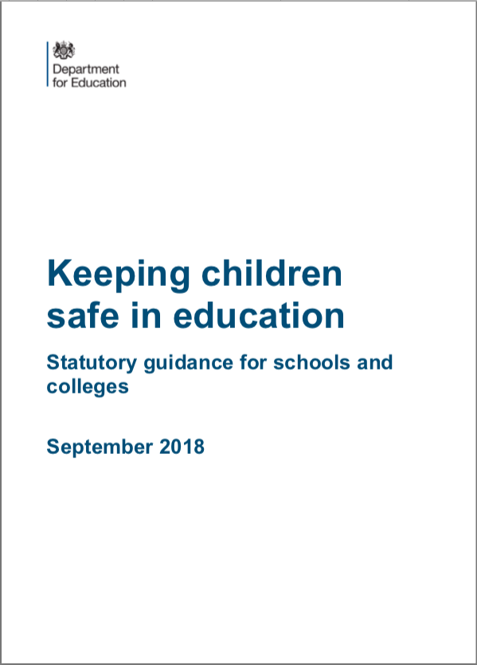**19 September 2018: Keeping Children Safe in Education**

I expect all school leaders have read this updated guidance by now. If not it can be found [here](https://www.gov.uk/government/publications/keeping-children-safe-in-education--2). A list of changes made since the last publication is on page 104 of the document – Appendix H. The point of this piece is to outline what school leaders need to do in order to meet new requirements.

If you are in the habit of going above and beyond some of the items listed below might already form part of your usual practice but it is necessary to state them because for everyone else:

* Ensure that all managers and school leaders have read the updated guidance in full and noted all the changes including a brand-new part 5 – which is about managing child on child sexual violence and sexual harassment
* Ensure that all staff members have read at least part 1 of the guidance, they should confirm this by providing a signature
* Ensure that staff have understood the guidance – some schools ask staff members to complete an assessment focused on the changes; others use regular staff meetings to discuss the changes and ensure that all staff are clear about their responsibilities
* Collect more than one emergency contact for every pupil where possible – this will mean amending your application/referral forms; adding an extra column on your admissions register; amending the emergency contact sheet that accompanies risk assessment forms for activities outside the school
* Ensure that staff know how to proceed with a safeguarding concern if for whatever reason both the DSL and deputy are not available – contact child social services directly or a senior manager and report to the DSL or deputy when they return
* Make arrangements for staff to learn about “Child on child sexual violence and sexual harassment” – ensure that they know how to proceed if they have a concern or if they receive a receive a report from a child
* Ensure that all staff understand that GDPR does not prevent or limit information sharing for the purposes of keeping children safe – you could
* Update their child protection policy to include the matters listed on page 24 of the guidance
* If your school has a “no contact” policy, you are encouraged to consider adopting policies that allow the use of reasonable force where it is appropriate to safeguard children
* Check current procedures regarding external staff who are supervised and therefore for whom the school does not conduct a barred list check. School leaders must ensure that the supervisor is in regulated activity; that supervision is regular and day to day; that supervision is reasonable to ensure the protection of children.
* Ensure that the new guidance about employment history and references is followed during staff recruitment – references should always be sought from the current employer; where candidate is not currently employed verify their most recent employment; where electronic references are received, ensure that they originate from a legitimate source
* If using alternative provision, ask for written confirmation from the provider that they have conducted the appropriate safeguarding checks on their staff. If you offer alternative provision to other schools be ready to confirm the same.

**Free resources attached**

* **Scheme of work evaluation template**
* **Lesson Plan evaluation template**

**Marell Consulting Limited News**

Come to our Autumn 2018 training workshops!

It’s the beginning of the new academic year, time for self-evaluation and improvement planning. You are invited to three training workshops exclusively for Headteachers and SMTs or SLTs of independent schools inspected by Ofsted.

The workshops will be in Birmingham and tickets go on sale this coming Monday, the 1st of October through Eventbrite. To ensure comfort at the venue only 28 tickets will be sold for each workshop and you can choose to attend a morning or afternoon session.

To book your place, look below for links to our Eventbrite pages:

* [Self-evaluation: getting it right!](https://www.eventbrite.co.uk/e/self-evaluation-getting-it-right-tickets-50824786304) – Friday, 19 October 2018:
* [School improvement plans: compile, implement, monitor evaluate](https://www.eventbrite.co.uk/e/school-improvement-plans-compile-implement-monitor-and-evaluate-tickets-50825836445)- Friday, 16 November 2018:
* [How to ensure continuous improvement](https://www.eventbrite.co.uk/e/how-to-ensure-continuous-improvement-tickets-50825985892)– Friday, 14 December 2018: