What’s New?
For school leaders of Independent Schools inspected by Ofsted

Volume 2: November 2018

Ofsted News

This section includes commentary on relevant news published by Ofsted since the last issue of the newsletter. The focus is on how any changes might affect non-association independent schools.

The 2019 Education Inspection Framework
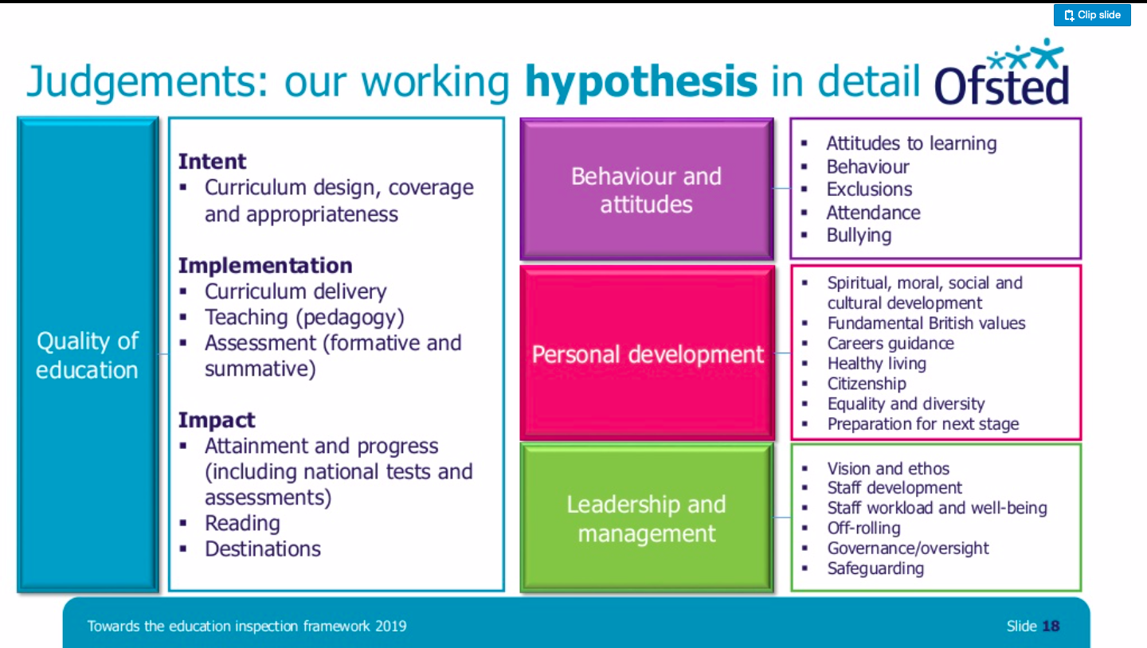
In last month’s newsletter I tried to predict how the new inspection framework might demonstrate Ofsted’s new focus on the curriculum. I imagined that the curriculum might be included under the “Effectiveness of leadership & management” judgement area - it turns out that the curriculum will be covered under a new judgement area - “Quality of education". This new judgment will also include what was previously covered by the “Quality of Teaching, Learning & Assessment” and “Pupil Outcomes” judgment areas as can be seen on the left. There will be a consultation about the new inspection framework in Spring 2019 so please be ready to share your views. Ofsted recently published slides about the new framework and these are some of the key points I took away about the new inspection framework:
- It will be based on solid research evidence about educational effectiveness and valid inspection practice
- It will not include a separate judgement about pupil outcomes
- It will still have four main judgement areas – Quality of Education; Behaviour & Attitudes; Personal Development; Leadership & Management
- It will still have a strong focus on safeguarding
- The curriculum will be at the heart of the framework
- Outstanding schools will no longer be exempt from routine inspection

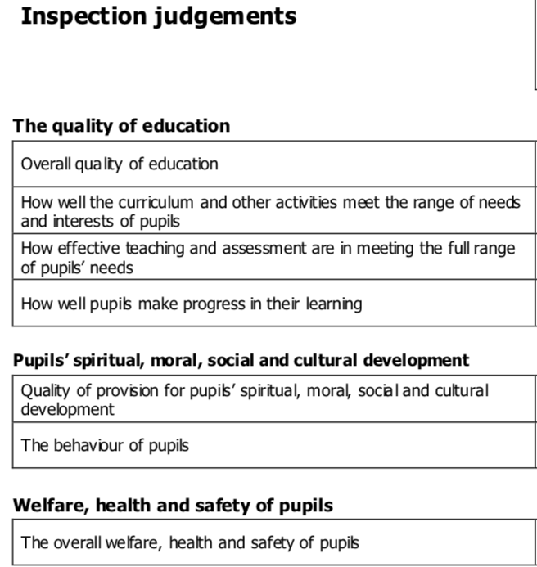
Unlike other schools that are required to follow the national curriculum, independent schools have always been free to design their own curriculum - with guidance from paragraph 2 of the Independent School Standards of course. Hopefully the new inspection framework’s focus on the curriculum will not be too much of a departure from current practice for leaders of independent schools. School leaders will of course need to take into account the available research to improve the way they design, implement and evaluate their curriculum.

It is also interesting to note that under a previous inspection framework (shown on the left – The framework for inspecting education in non-association independent schools, 2012) the composition of the “quality of education” judgment closely resembles the one that is being proposed on the new framework, another advantage for non-association independent schools.

Look out for the consultation on this new framework in Spring 2019. We will let you know when it is published via Twitter, LinkedIn and this newsletter.

Book of the Month

Title: TES Research Series Volume 2
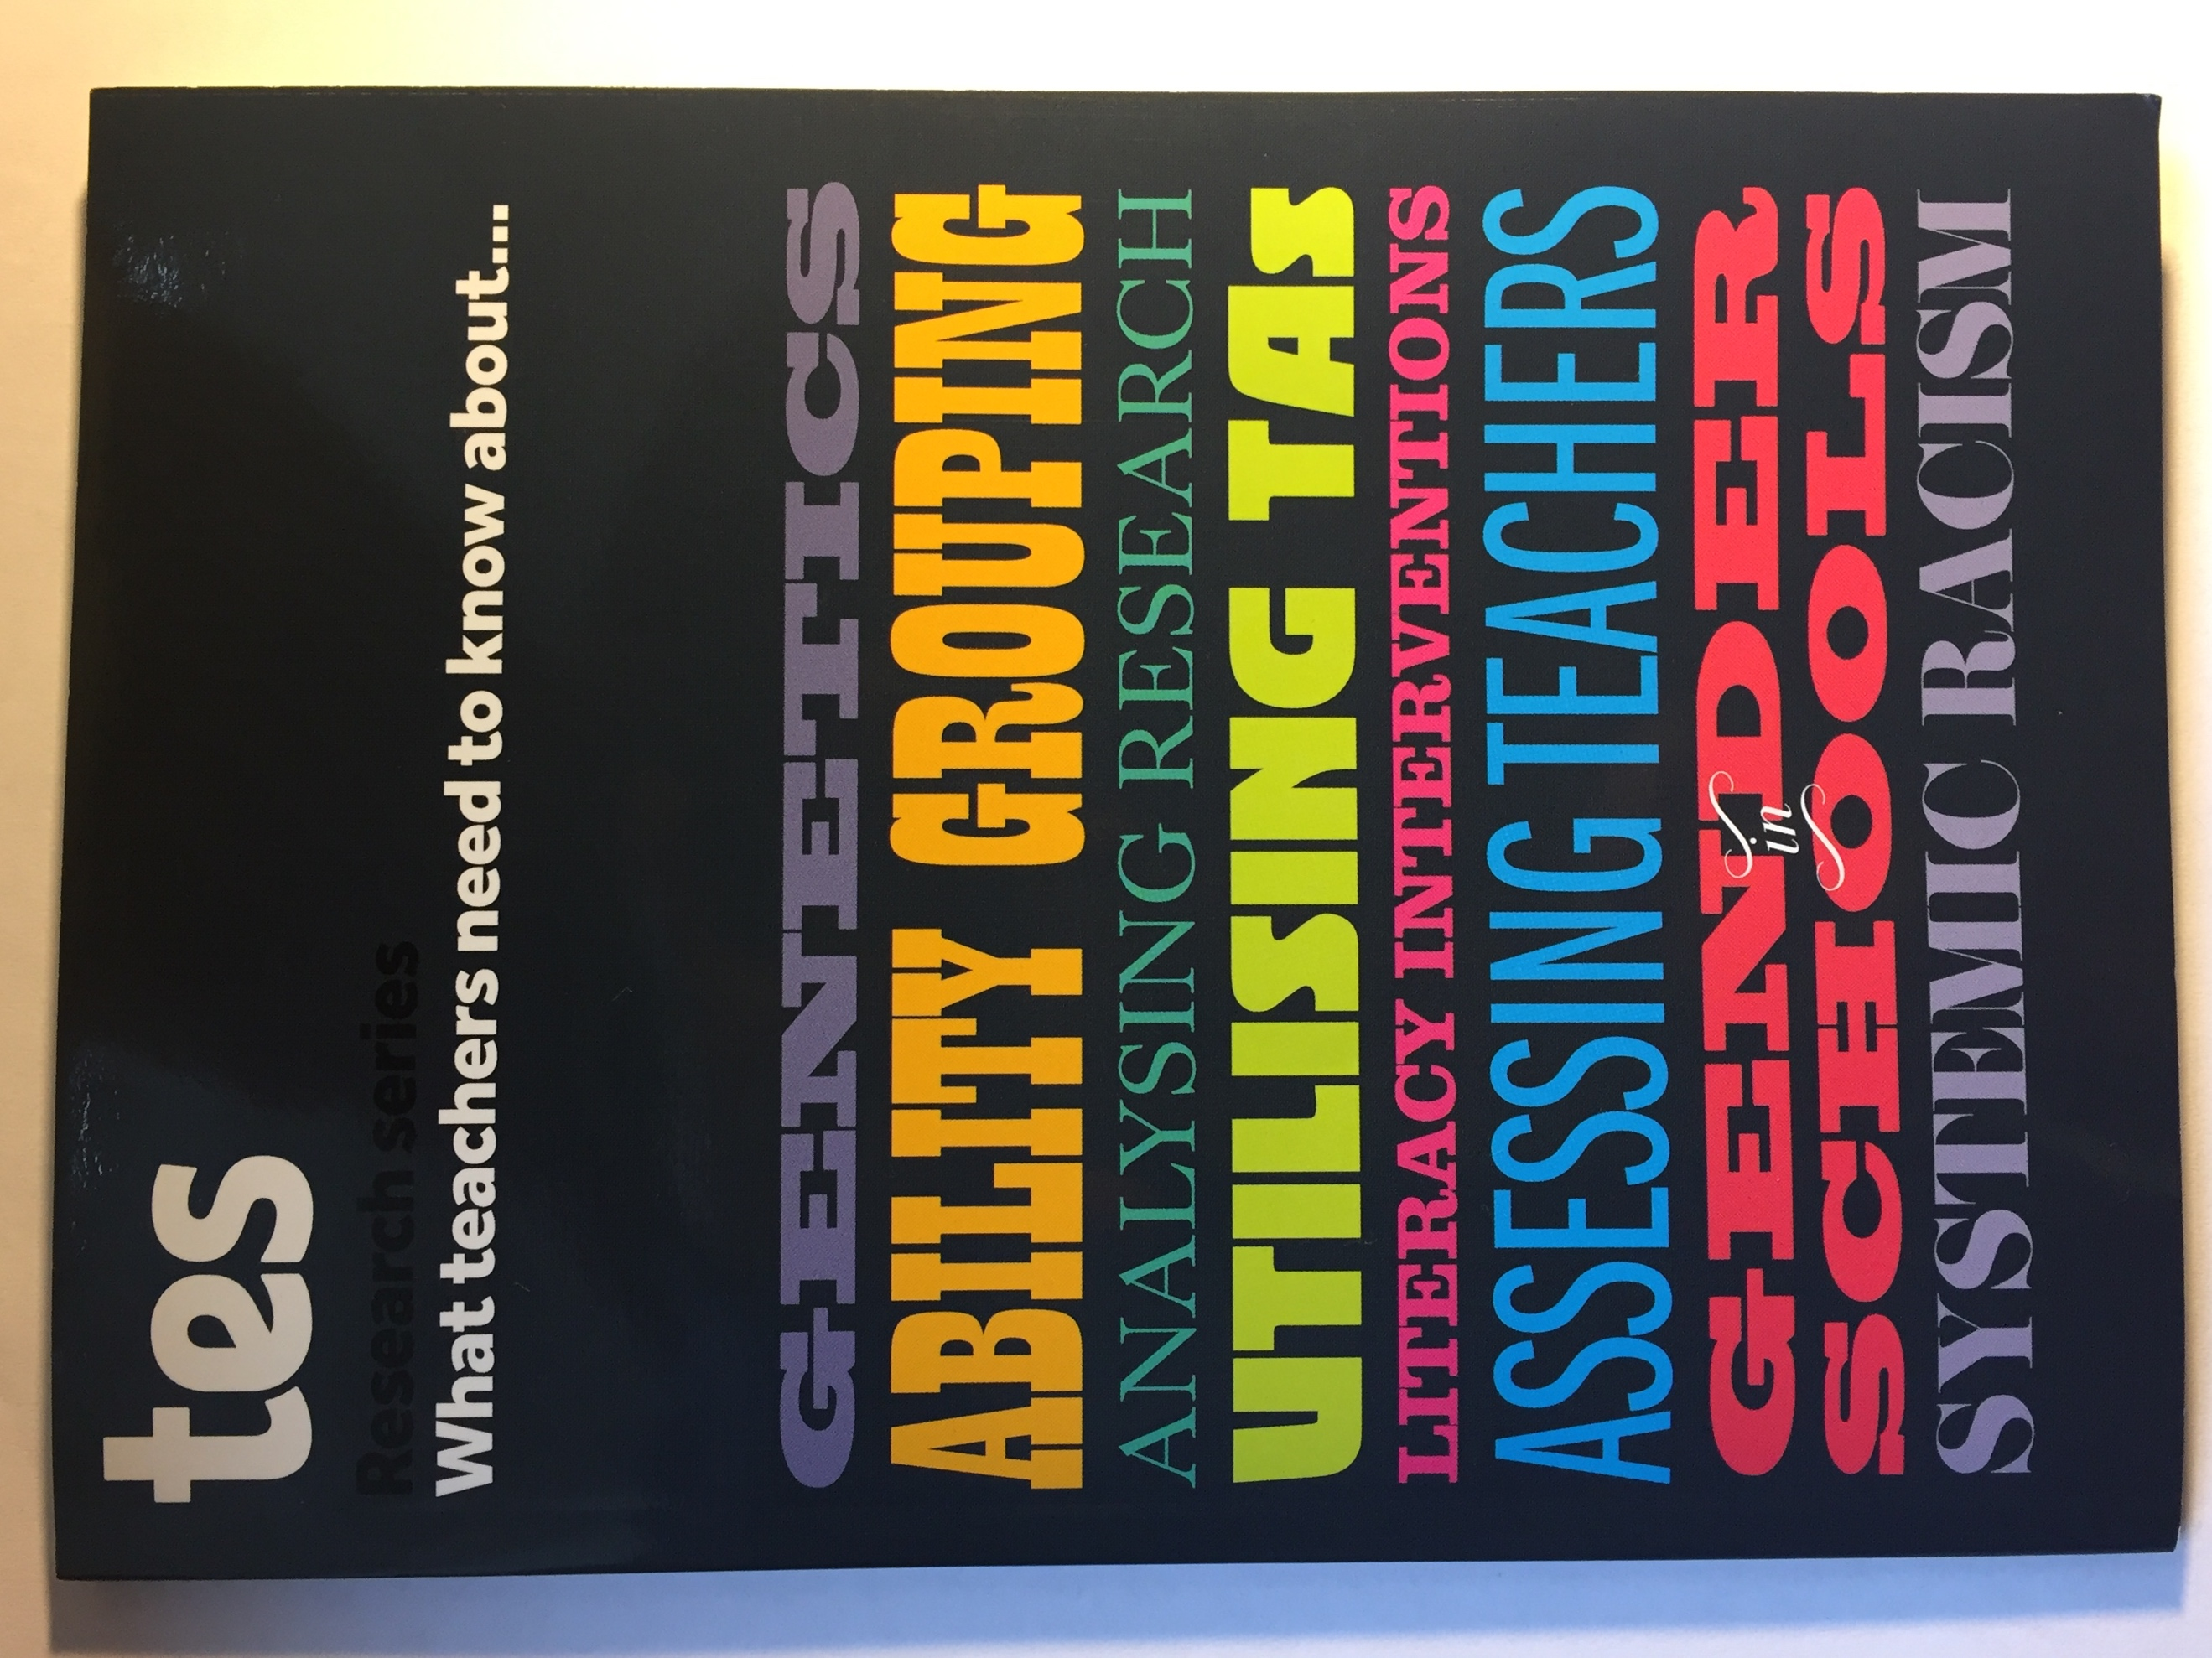
Authors: Tes Editorial

What is it about?: It is a collection of edited transcripts of interviews with academics about a variety of topics that would interest teachers and school leaders.

Just like last month, the book I am discussing was one I pre-ordered because it piqued my interest. It was published in October 2018 and is available to purchase for just £9.99 here. What caught my eye was a chapter titled “Evaluating teacher and school effectiveness”, I am always keen to read research about school effectiveness. When the book was delivered, I found out that the that the academic interviewed for this chapter, was the head of research at Ofsted, Daniel Muijs so I definitely wanted to hear what he had to say. In his interview he talks about the importance of using a holistic approach to evaluate teaching; the importance of context in evaluating school effectiveness; the challenges posed by the many variables that need to be considered when evaluating a school; how bias during school inspections or peer evaluations, can be reduced if those conducting the evaluation have some research knowledge. The chapter concludes by pointing out that there are many areas in education that are yet to be researched and more work needs to be done to translate research findings to practice.

What struck me the most in this chapter was that when evaluating teacher effectiveness, we sometimes rely heavily on pupil attainment as an indicator of teacher effectiveness forgetting that pupil attainment cannot be attributed only to what the teacher does.

I also found it interesting to read about research which shows that within schools that practice streaming, the reason that pupils in lower attainment groups do not make as much progress as their peers is not because they are less capable but because they are disadvantaged further by being allocated less qualified, less experienced teachers. The chapter, titled “Ability grouping and setting” based on an interview with Professor Becky Francis, director of the UCL institute of education got me re-thinking my position on ability groups and setting.
I would recommend this book, I am sure you will find a topic that interests you amongst the following:

- Spotting research myths
- Tackling literacy problems in secondary schools
- The role of genetics in education
- How to judge teacher and school effectiveness
- Why you’re probably not making the most of your teaching assistants
- What every teacher needs to know about setting
- Gender stereotyping in schools – its damaging effects and how to prevent it
- Understanding race in education

I hope you enjoy reading it as much as I did and that you can take away something useful. Buy it for £9.99 from Tes here.

DfE News

This section includes relevant news published by the DfE since the last issue of the newsletter. For all news items the focus is on the impact of changes on current practice in non-association independent schools.

16 October 2018 - Key Stage 4 & 5 Destinations  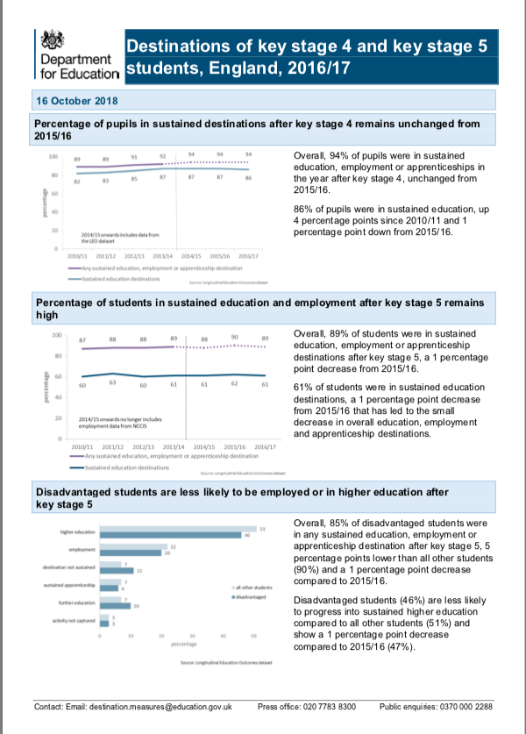  These are statistics about the number of young people moving into education, employment and apprenticeships the year after they complete Key Stage 4 or Key Stage 5. These statistics published by the DfE since 2010 are available on GOV.UK and are useful for benchmarking your pupils’ progression on to positive destinations. The destinations of young people from independent schools are not included in these statistics therefore I would advise that you read the article about benchmarking in this newsletter to find out how you can make these statistics useful for you. | 18 October 2018 - Absence Statistics  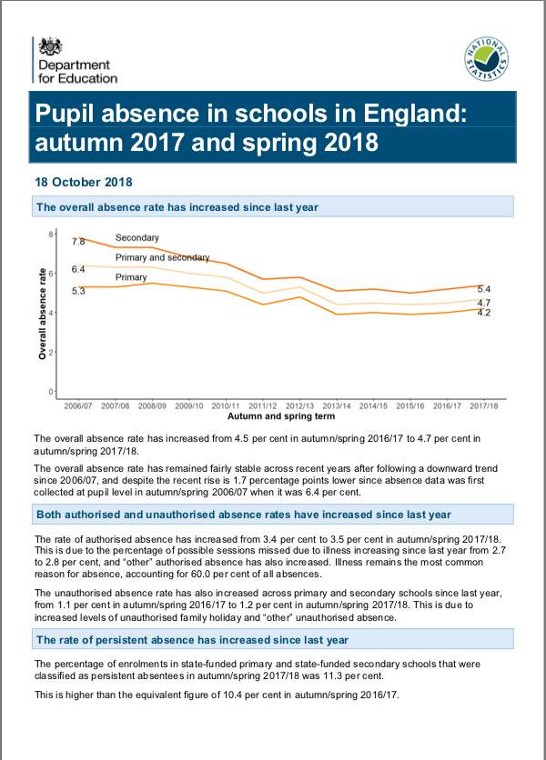  These are statistics on overall authorised and non-authorised pupil absence by school type including persistent absentees and other pupil characteristics. Again, statistics from 2010 onwards are available on GOV.UK and they are published three times a year. Non-association independent schools are not included in these statistics however if you read the article about benchmarking in this newsletter you can find out how to make use of these statistics.
23 October 2018 - Female Genital Mutilation Guidance

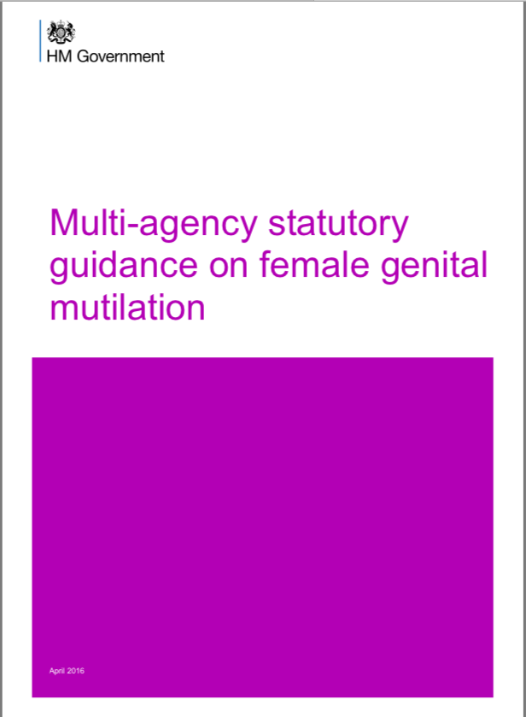
This guidance has been factually amended, please read it again. It provides information and strategic guidance on FGM and most importantly, it provides advice and support to front-line professionals who are responsible for safeguarding and supporting those affected by FGM. It is important for staff at your school to receive training about FGM. If they haven't already been trained there is free online training here. Your staff should be able to identify girls who are at risk of FGM and those who have had FGM. They should also know how to respond appropriately. Staff should know the difference between the procedure for dealing with suspected cases of FGM and known cases of FGM. They should be aware that based on the nature of the profession, they can only know that FGM has taken place if a girl discloses this information. And most importantly, staff must comply with the mandatory reporting duty which falls on them (not the DSL) if they receive an FGM disclosure. More information about that duty can be found here. Finally, staff should know that they can be sanctioned for failing to meet the mandatory reporting duty.

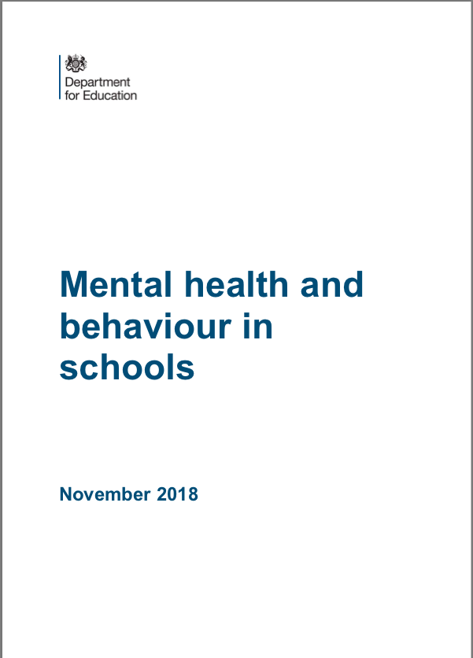
12 November 2018: Mental Health and Behaviour in Schools

This guidance is for school staff and applies to all schools. It gives advice about:
- how to create a whole school culture, including promoting positive mental health
- understanding the link between mental health and behavior
- how to identify children with possible mental health problems
- where and how to put in place support, including working with external agencies where required

It also provides links to sources of further support and guidance

Marell Consulting Limited News & Articles

Why some schools fail to comply with the Independent School Standards (2014)

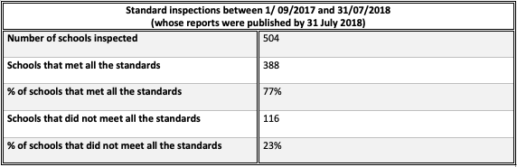
23% of independent schools that had a standard inspection between 1 September 2017 and 31 July 2018 (and whose report was published by the 31st of July 2018) did not meet the requirements of the independent school standards. 57% of independent schools that had follow-up progress monitoring inspections during the same period also failed to meet the requirements of the standards.

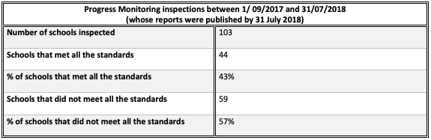
Meeting the requirements of the standards is the single most important mandate for all independent schools. Those of you who are proprietors know that, when you register an independent school the DfE gives you only one condition of registration-that you comply with the Independent School Standards (2014). Before an independent school can open its doors the DfE commissions Ofsted to inspect the school to find out if it is likely to satisfy this regulation. During a school’s first year of operation Ofsted are sent in again to check if the school complies with the standards. Non-compliance with the standards can lead to loss of an independent school’s registration status and it is illegal to operate a school without this registration. So, why are schools failing to meet the requirements of the standards?

During my work with schools I find that sometimes, the importance of complying with the standards is not always communicated to Headteachers by Proprietors. If a Headteacher is coming from a mainstream background, they can be unaware of the existence of this critical regulation. I have also found that it is almost impossible to meet the requirements of the standards by just reading the standards. The fact that Ofsted and now the DfE have produced supplementary documents to help interpret the standards supports my assertion.

As school leaders I expect that you have spent time reading the Independent School Standards (2014) document. It is presented in legal language. Although some of the requirements are straightforward, the majority of the standards need interpretation or more detail, for example:

“7. The standard in this paragraph is met if the proprietor ensures that—(a) arrangements are made to safeguard and promote the welfare of pupils at the school and: (b)such arrangements have regard to any guidance issued by the Secretary of State.”

Questions that arise: What arrangements? Which guidance, specifically? Ofsted published a guidance document “Completing the record of inspection evidence and judgments” (January 2014) which details their interpretation of the standards and their approach to evaluating how well schools comply with the standards. This is a very useful document which spells out what is required in great detail. Unfortunately, when the standards were updated in December 2014 Ofsted did not update their guidance. They have however updated the Non-association independent school handbook to include a section about compliance with the standards. This section includes links to various documents that give important additional information for example advice about school premises and first-aid.

The DfE have recently published a draft document “The independent school standards: advice for independent schools” (March 2018) it was produced to help proprietors and others understand their obligations under the independent school standards. It is a useful guidance and has the most up to date guidance about SMSC. So, it is clear that there is enough guidance available to help school leaders understand the requirements of the standards so why are some schools failing to comply with the standards? Perhaps they are unaware of the additional guidance or have not yet taken the time to read it in detail? Anyway, I imagine that even with all the guidance it must be a bit challenging to check your schools compliance when you need to make reference to so many documents.

Some of you have come across Ofsted’s Independent school standards compliance record and maybe you use it as a template to check how well your school complies with the standards. If you have attended recent Ofsted conferences for Independent Schools, you will have been given an updated version of this document. I came across the first document in 2015 - I thought it was a useful tool, but because it lists the standards exactly as they appear in the legislation, I still needed to refer to additional guidance. I decided to use the guidance in Ofsted’s “Completing the record of inspection evidence and judgments” (January 2014) to compile a set of questions for each standard that would make the requirement clearer for those of us who are not inspectors. I completed the first version of this document in May 2015.

I have since updated that document and the third version titled “Independent School Standards Compliance Audit Tool” is a self-evaluation tool for use by school leaders to accurately evaluate the extent to which their schools meet the requirements of the Independent School Standards (2014). The wording of the standards is not included on this document. For each standard, there is a set of questions that require a yes/no response to determine if your school meets the requirements of that standard. The questions were compiled with reference to:

- Ofsted’s “Completing the record of inspection evidence and judgments” (January 2014) which details Ofsted’s interpretation of the standards and their approach to evaluating how well schools comply with the Independent School Standards (2014)

- The DfE’s draft document “The independent school standards: advice for independent schools” (March 2018) which details the DfE’s guidance produced to help proprietors and others understand the obligations under the independent school standards

- Additional specialised guidance documents that are referenced in Ofsted’s “Non-association independent school inspection handbook” (September 2018) pages 76 - 93

In order to get an accurate picture of your school’s compliance it is important to answer the questions honestly, ensuring that your response can be backed up with evidence and that your daily practice supports your responses.

I have used this approach successfully with several schools. You can buy it here.

Benchmarking for non-association independent schools
When evaluating your school’s performance, you might compare the outcomes of different groups of pupils; the outcomes of different cohorts of pupils and for those who have multiple school sites, the outcomes of pupils at different sites. It is also important to compare your school performance to national and local benchmarks whenever possible, to get an idea of how well you are serving your pupils compared to similar school. As the leader of a non-association independent school you might find it challenging to identify benchmarks that include your type of school. In this article I will identify the challenges you might face and provide tips on how to overcome them.

The advice in this article does not apply to all non-association independent schools. It is for those schools that have at least one of the characteristics below:

- they offer alternative provision for pupils referred by the local authority or other schools
- they cater for pupils with severe complex needs that affect their independence
- they cater for pupils whose cognitive ability is such that their attainment is unlikely ever to rise above ‘low’

Absence
The DfE’s Performance Tables include data about pupil absence. If you are looking to use these tables to compare your pupils’ absence rates with that of other independent schools, you will find the following message next to each independent school - ‘No data available or applicable for this school or college”. Absence data for independent schools does not appear on performance tables.

The DfE also publishes absence statistics three times a year. This would be a great benchmark to use to compare your pupil’s absence rates to that of other pupils nationally or locally. Unfortunately, you will also find that even though there is data about independent schools in these statistics - it is not about non-association independent schools. Having said that, depending on the characteristics of your school, you can use the information available to make meaningful comparisons. This is how you do it:

- If your school delivers education to pupils referred by the local authority compare your absence rates to those of PRUs (pupil referral units). Your pupils are referred to you because they have been excluded or are about to get excluded. Usually they have poor attendance or have been out of education for extended periods. Their characteristics are similar to those of pupils at PRUs.

- If you are the leader of an independent special school, you might think – “there is data about pupils with special educational needs and data about other independent schools in these statistics - I can use this data”. This might work if your pupils are not referred to you by the local authority. If they are, in addition to their special educational needs they have other issues that have made it necessary to exclude them from mainstream education and usually attendance is one of those issues. I would still compare my pupils to those at PRUs.

- If you can work in collaboration with other non-association independent schools like yours, you could as a cohort make valid comparisons that can be used as a benchmark as long as your contexts are similar.

- If it is not possible for you to use benchmarking, you could focus on analysing individual pupils’ improvement in attendance over time as a good measure of how well your school reduces absence. In order to do this effectively it is important to capture pupil’s previous attendance record at the point of referral including periods during which pupils were out of education.

- Finally, I would suggest and that when summarising pupils’ attendance, in addition to giving the overall attendance or average attendance you also report the overall attendance excluding that of pupils with extremely poor attendance.

Key Stage 4 & 5 Destinations

The DfE’s Performance Tables also include information about pupils’ destinations after Key Stage 4 & 5. Again, here you will find that there is no information published for independent schools. The website has the following message, “We don’t publish destination measures at Key stage 4 or 5 for independent schools”. The DfE also publishes statistics about pupils’ destinations after Key Stages 4 & 5. Again, these statistics do not include information about independent schools. There are two possible options for you to benchmark your school’s performance:

- If your school delivers education to pupils referred by the local authority compare your destinations to those of Alternative Providers, that is the group which most closely relates to your school.
- If you are an independent special school, you can compare your destinations to that of other special schools as long as you are aware that the special schools referred to in these statistics are state funded and non-maintained special schools. This, however would not be a good benchmark for independent special schools that deliver education for pupils referred by the local authority - they are better off using statistics for Alternative Provision.

It's important to note here that the destination statistics in this data are sustained destinations. This means it's not just about helping pupils move on to the next stage it is about checking to see if they stay for at least two terms. So before using this benchmark make sure that you check if your pupils’ destinations are sustained.

Progress
The DFE's latest benchmark for progress is called Progress 8. If you check the DfE’s Performance Tables, you will find that there is no information provided for independent schools. The website states “We don’t publish Progress 8 data for independent schools at key stage 4. This is because the majority of pupils at independent schools do not have prior attainment data, which is needed to calculate progress.”

Unfortunately, here the only advice I can give is to use the benchmark that was replaced by Progress 8 - Expected Progress. It is a measure which was used to define the amount of progress pupils were expected to make in Mathematics and English between Key Stage 2 and Key Stage 4. The measure was based on the discontinued National Curriculum levels. The measure states that pupils who achieve National Curriculum level 4 in English and Mathematics at the end of Key Stage 2 are expected to achieve GCSE grade C at the end of Key Stage 4. Of course, now at Key Stage 2 we will be talking about a pupil achieving “the standard” which is a scaled score of 100. At Key Stage 4 we will be dealing with GCSE grade 4. So, if your school educates pupils for the full 5 years covered by this measure it should be easy to apply. You will need to convert the old GCSE grades to the new grades 1 to 9 and you will need to start with the assumption that the scaled score of 100 at Key Stage 2 is equivalent to National Curriculum Level 4.

If, however your school however educates pupils for only part of the 5 years covered by the measure you might need to be creative. According to the Expected Progress measure pupils move from National Curriculum Level 2 to GCSE grade C in 5 years – this represents 3 full levels of progress in 5 years. Using that as a starting point you can easily work out how much progress is expected in a shorter period of time. In your case, because pupils do not always join your school in Year 7 and some might be out of education for long periods of time before they come to you - in addition to knowing their prior attainment at Key Stage 2 you will also need to capture their starting points accurately when they get to your school. In this type of school, benchmarking might not be as useful as monitoring small steps in progress from pupils’ starting points.

If you would like to discuss any of these matters further, please feel free to contact us at enquiries@marellconsulting.co.uk

Free resource attached: Key Performance Indicators for Self-Evaluation

Upcoming training:

How to ensure continuous improvement – 14 December 2018
This course will help school leaders create a system to manage continuous improvement within their schools in order to ensure that they are always striving towards delivering an outstanding quality of education. Each delegate will leave with a strategy that can be applied immediately to manage:

- the monitoring of every aspect of the provision
- accurate self-evaluation
- effective improvement planning
- implementation of improvement plans

Book your place on Eventbrite.

